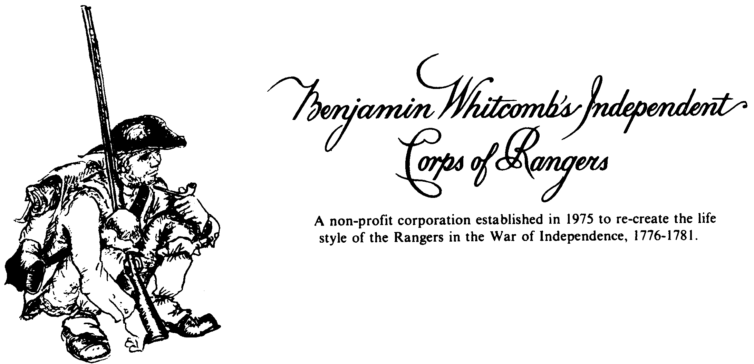

826 Lincoln Hill Road.
Shrewsbury, Republic of Vermont 05738
July 30, 2026

Greetings,

Thanks for your interest in Whitcomb’s Rangers. We feel that our organization is one of the best in the American Revolution segment of the living history hobby and we welcome any inquiries regarding information and membership.

Along with this letter are a couple of other pages of information relating to our unit. The first is a brief explanation of what we are about and what we do. The second is a membership form that, should you decide to join us, you need to print out, fill out, and return to me with a check made out to Whitcomb’s Rangers for $25.00. A portion of the money ($15.00) covers your dues and the remainder ($10.00) is for a copy of the Ranger Manual—a 100+-page notebook covering many aspects of the hobby and of Whitcomb’s Rangers. The last is a short history of the original unit. For additional details about us, you can access copies of some of the latest news-letters and some pictures on our web site. Perusing these will give you a much broader picture of what the hobby and our unit are about. I will add your name to our mailing lists—postal and electronic—and, unless you request hardcopies mailed to you, you will receive notices and news-letters via e-mail.

You should attend some activities before deciding whether or not to join. Doing this gives potential members first-hand experience with the unit. You also should not purchase any equipment or clothing before talking with us. Invariably, this saves you money by preventing you from buying unacceptable items. Several of us have extra items of clothing and equipment which you could borrow for events until you build your own kit. When you decide which events you would like to attend, please contact us so that we can be sure you are registered with the unit and we can bring the equipment (we often do not carry extra items or use tents).

Again, thank you for your interest in Whitcomb’s Rangers. I hope the above-mentioned materials answer many of your questions. If you have others, feel free to write or call me at 802-492-6119 or e-mail me at anvilring@gmail.com.

I have the Honour to be Your most obedient and
humble Servant,

Jeff Monder

INTRODUCTORY INFORMATION
ON MEMBERSHIP

WHO ARE WHITCOMB'S RANGERS? A group of volunteers with a wide variety of interests who research and re-create an American unit which fought during the Revolutionary War in New England, New York, and Canada.

ACTIVITIES If a member wishes to take the time, there is something to do almost every weekend of the year. These events usually cover two days and include encampments, demonstrations of 18th-century life, working with other groups in mock battles, parades, and educating the public. Whitcomb’s Rangers attends approximately fifteen such events each year. In addition to the military, many people in the hobby research and recreate diverse aspects of the 18th-century world.

UNIFORM Research indicates Whitcomb's Rangers had no specific uniform but rather used a wide variety of military and civilian clothing and equipment including French-Canadian. Authenticity is a major goal and the unit has sources of supply for high-quality reproductions or patterns for those who wish to make their own.

FAMILIES This is a hobby and families are encouraged to participate. Since authenticity applies to all who take part, the unit has several sources and patterns for women's and children's clothing.

ENCAMPMENT The group sets up and lives in an 18th-century camp for events. An area for modern camping is usually provided as well. Many of us just sleep on the ground or under lean-tos.

DUES Annual membership is $15.00 and there is no additional fee for non-combatant family members. Upon joining, there is an additional, one-time-only $10.00 charge for a copy of the Ranger Manual, a loose-leaf book covering many aspects of the group and the hobby. Members are covered under the unit's liability insurance and they receive the nearly-monthly Morning Report. This news-letter covers all aspects of the operation and history of the unit specifically and of the 18th century in general.

WHAT WILL YOU GET OUT OF THIS? You will visit many historic sites and be part of the show rather than a spectator. You will become friends with scores of interesting people depicting various elements of military and civilian life from both sides of the conflict. You will learn a great deal about life during a period of history that changed the world forever and which is relatively unfamiliar and foreign to most people. You will gain a high level of satisfaction talking with and educating visitors at events. Most of all, you will have fun doing these things.

MEMBERSHIP FORM
(Please type or print)

NAME: DATE OF BIRTH:

MAILING ADDRESS:

ZIP:

PHONE NUMBER: ( ) E-MAIL:

SPOUSE’S NAME: ___________________________

CHILDREN’S NAMES: _______________________
(use back if necessary)
________________________

LEVEL OF MEDICAL TRAINING:

NAME OF CONTACT PERSON IN EVENT OF INJURY:

ADDRESS:

PHONE: ( )

LIST ANY MEDICAL INFORMATION WHICH WOULD AFFECT TREATMENT IN EVENT

OF INJURY (Use back if necessary):

I agree to abide by the rules and guidelines of Whitcomb’s Rangers, Inc.

Signature: Date:
(If under eighteen years of age, a parent or guardian must also sign below.)

Signature: Relationship:

A Short History of the Original Corps

Following the disastrous Canadian campaign of 1775-76, the American army needed to gather information on British activities in Canada. The scouts who took on this task needed to traverse over one-hundred miles of wilderness between the American positions at Ticonderoga and Mount Independence and those of the British along the Sorel River and around Montreal. A lieutenant from New Hampshire, Benjamin Whitcomb, quickly demonstrated his willingness and ability to perform these hazardous activities. On one such mission, while watching British movements near St. Johns, Whitcomb mortally wounded the commander of the British First Brigade, General Patrick Gordon. Calling Whitcomb and the men with him “infamous Skulkers,” Canada’s Governor-General Carleton offered a reward of fifty guineas for the capture of the scout and promised "due punishment, which can only be inflicted by the Hangman." Less than a month later, Whitcomb went back to the same place and captured a corporal and the quartermaster of the 29th Regiment (General Gordon’s regiment). As a result of his prowess, General Horatio Gates recommended that Whitcomb be given a command and on October 15, 1776, Congress promoted Whitcomb to captain and ordered him to form two companies of rangers. With that order, Benjamin Whitcomb’s Independent Corps of Rangers became part of the Northern Department of the Continental Army.
Whitcomb's Rangers functioned primarily as scouts and spies. Small groups of up to six men traveled behind British lines for days or weeks at a time. Several times, British intelligence reported them to be dressed as Canadians or Indians. The unit, augmented with volunteers and other companies, also went out in pursuit of Indian and Loyalist raiding and scouting parties. On June 17, 1777, men of Whitcomb's Corps fought the first action of Burgoyne's campaign when Indians functioning as a screen for the advancing British army ambushed fourteen Rangers on a scouting mission. Subsequently, some of the Rangers took part in the actions at Hubbardton, Fort Anne, Bennington, and Saratoga (where they fought as part of Dearborne’s light infantry). Several of the Rangers also took part in Brown’s raid on the British and Germans garrisoning the Ticonderoga/Mount Independence complex.
After the surrender of Burgoyne, Whitcomb received orders to serve as major in a regiment organized for an incursion into Canada under Lafayette. In early 1778, as part of those plans, the corps moved to Rutland, Vermont, where they built Fort Ranger which ultimately became the military headquarters for the Republic of Vermont. That fall, Whitcomb’s Rangers played a significant role in detecting and limiting the success of a "secret" British expedition to burn mills and sources of supplies in the Champlain valley. The Rangers had known of the pending raid for several weeks.
During the winter of 1778-79, Whitcomb’s Rangers moved to the upper Connecticut River valley, then known as “Coös,” on the east side of Vermont. As well as continuing to scout into Canada, the corps guarded the men working on the Bayley-Hazen Road which had been begun with the intention of serving as the route for the second invasion of Canada. Much of the responsibility of protecting the region fell to Whitcomb Rangers and three companies of short term men. In October of 1780, the British and their allied savages attempted a raid into Coös in order to capture Whitcomb (the reward still stood) and to destroy any war-making capabilities of the region. A few miles before they reached Coös, a spy reported that Whitcomb had 500 men with him and the raiders decided to attack the White River valley instead. The area around Royalton suffered severely and the raid became a legendary piece of Vermont’s history.
Whitcomb’s Rangers carried on their service until the army’s reorganization in early 1781. At that time, the officers retired and the enlisted men joined the light companies of the New Hampshire regiments.
The Rangers had no specific uniform but rather utilized a wide variety of civilian and military clothing and equipment including brown and red Lottery Coats. The army issued smooth-bore muskets and bayonets to the Rangers but no reference to rifles has been encountered. At no time did the Rangers receive enough clothing and equipment for all the men. They must have presented a truly mixed appearance.
Less than eighty men, many in their teens, served as Whitcomb's Rangers and nearly all of them came from New Hampshire and “the Grants” (a common term for Vermont). The entire unit seldom found itself together because individuals and small groups continually received orders to serve in various areas or with other officers. Many others in the army knew about the corps. Whitcomb appeared in Morristown, New Jersey, conferring with Washington, himself. Benjamin Whitcomb’s Independent Corps of Rangers had a reputation that belied its small size but time has nearly erased the memory of these men. They deserve better.
Bringing to light the exploits of the original Whitcomb’s Rangers is one of the major objectives of the re-created Whitcomb’s Rangers. Formed in 1975, the members of this non-profit organization continue to conduct extensive research into the original Rangers and the period of the American Revolution. Using that information, the men, women, and children of the modern-day Whitcomb’s Rangers attempt to re-create to original Rangers and their period of history to the best of their abilities. The unit utilizes a wide variety of civilian and military clothing and equipment. Members often forsake tents for a lean-to or simply blankets and are issued period rations for some events. Research is being done so that some members can appear dressed “in the Canadian manner.” As a result of their efforts, these volunteers have achieved a high level of authenticity and have acquired an excellent reputation within the living history hobby. We hope our efforts result in a public more knowledgeable in the period of the American Revolution and, of course, in Whitcomb’s Rangers. We also hope our efforts have made the original Whitcomb’s Rangers proud of us.

